<https://maker.pro/raspberry-pi/projects/build-raspberry-pi-rover-robot-smartphone-control>

Camera and remote-control use.

<https://www.redpah.com/product/2439/martian-rover>

Mars Rover Original Documents

<https://www.youtube.com/user/sentdex>

Python Object Recognition and AI stuff

<https://www.youtube.com/channel/UCWMcztkN_I4TlTvE8nSC0Tw/playlists>

Intro to Python

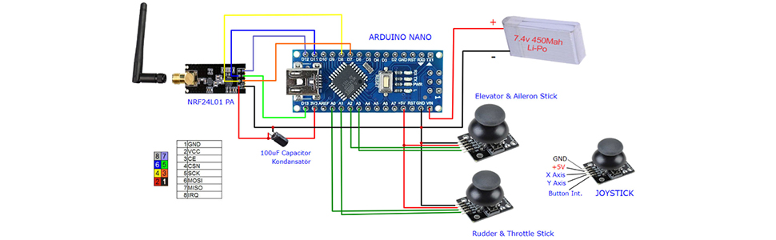

https://howtomechatronics.com/tutorials/arduino/arduino-brushless-motor-control-tutorial-esc-bldc/